**Challenge 5 Analysis**

**By: Siobhan Scott**

**Overview**

This challenge was to use Matplotlib. The Python alternative for MATLAB is Matplotlib. MATLAB was developed in 1980 by MathWorks. MATLAB allowed scientists to perform numerical analysis and linear algebra without having to learn Fortran, a programming language which was currently being used for complex computations. I was given the task of adding statistical data to help demonstrate the relevance of the data, for stakeholders of PyBer a rideshare company.

**Analysis**

While working on my data for Pyber the ride share company I utilized several different ways to visualize the data. I used a box-and-whisker plot to identify any outliers in the rideshare count.

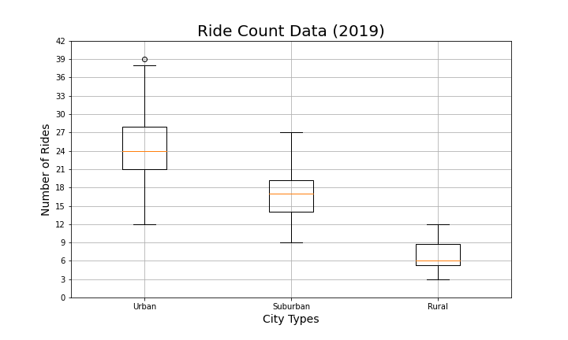The box_and_whisker plot gives the shareholders a visual diagram of the number of rides per city type. This will help the stakeholders to where their business is coming from. This would allow them to make better business decisions based on information from 2019.

The scatter plot allows the stakeholders to draw a correlation between the average fare by dollar amount and the total number of rides per city. This is important knowledge to have because not only does it show where the majority of your business is coming from, but it also allows you to see where your average fare is being generated.

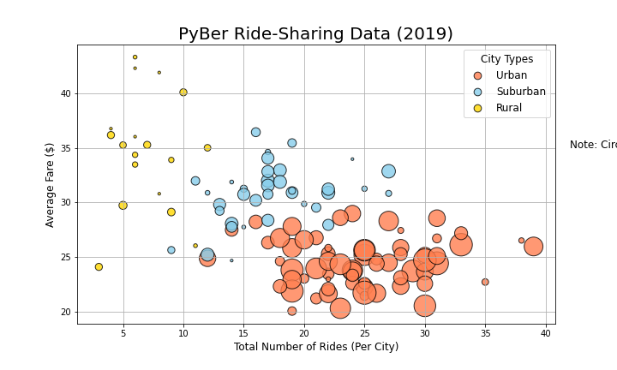

Pie charts are a way to show proportional data and percentages. The pie chart I created as a good way to show the percentage of drivers by city type. This pie chart shows the two smaller areas of the PyBer business as rural and Suburban, both having a lower percentage of business.

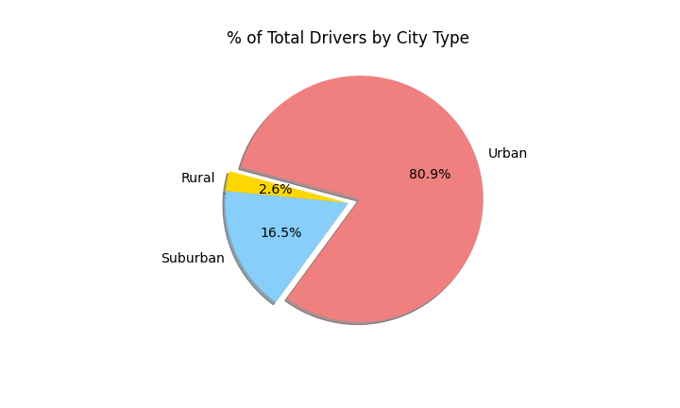**Challenges**

I found this challenge to be more interesting because data visualization appeals to me. I thought the hardest part of the challenge was dissecting and slicing the data to yield accurate information.

**Conclusion**

In Conclusion Pyber ride share stakeholders have several different ways of viewing data relevant to the business. Most of their business is being generated in the urban area with fares between $15 to $30. This data will allow them to change their business and make better informed decisions.